CS 250 Fall 2017 - Homework 01

Due 11:58pm Wednesday, August 30, 2017

**Submit your typewritten file in PDF format to Blackboard.**

The policy for all homework assignments this semester is as follows. Please sign, which you may do by typing in your name.

*In the following I have not represented the work of another person as my own nor have I knowingly or actively assist another person in violating this standard.*

(Signed)_**Farhan Shafi**_______________________________

1. How many distinct one-input Boolean functions are there?

For one input, distinct Boolean functions we will use 22^k. k is the number of inputs. This means there are 4 distinct one input Boolean functions.

1. What is the truth table for the three-input NAND (A, B, C) function? Extend the two-input NAND circuit in the text Figure 2.5 to accept three inputs and draw a schematic.

|  |  |  |  |
| --- | --- | --- | --- |
| X | Y | Z | Output |
| 0 | 0 | 0 | 1 |
| 0 | 0 | 1 | 1 |
| 0 | 1 | 0 | 1 |
| 0 | 1 | 1 | 1 |
| 1 | 0 | 0 | 1 |
| 1 | 0 | 1 | 1 |
| 1 | 1 | 0 | 1 |
| 1 | 1 | 1 | 0 |

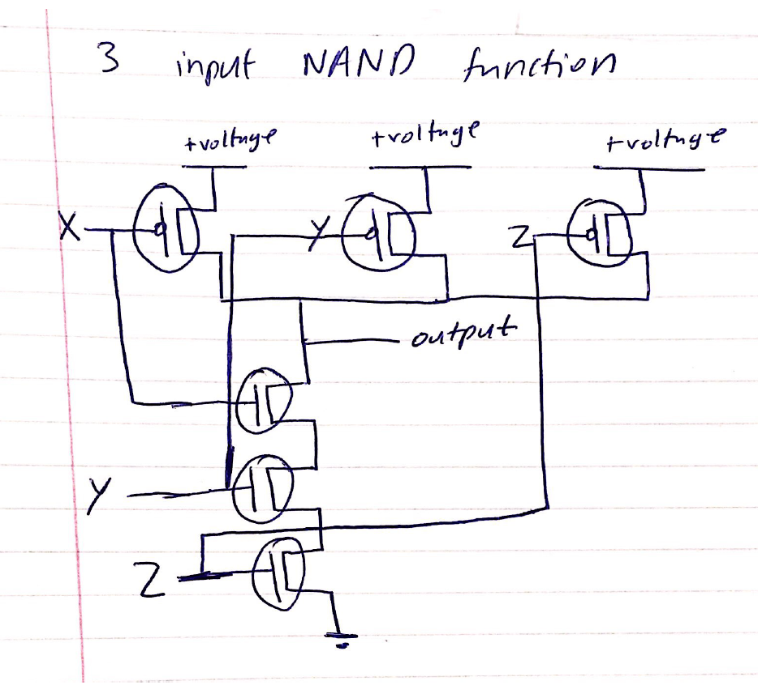

[Diagrams are a way of life for describing computer hardware designs and computer software logic flows. For CS 250 homework answers that require a schematic, I suggest that you hand-draw your answer neatly, then photograph or scan it, and import that image into the solution document you will print and turn in.]

1. Using exactly 4 CMOS transistors, design and then draw a schematic for a NOR circuit. Comment on the relationship you see between the NAND circuit presented in class and our textbook and the NOR circuit that you develop.

In the NOR circuit drawn the negated transistors are arranged in series and not parallel. In the NOR the non-negated transistors are arranged in parallel and not series. For NAND this is opposite. The negated transistors are in parallel and the non-negated are in series.

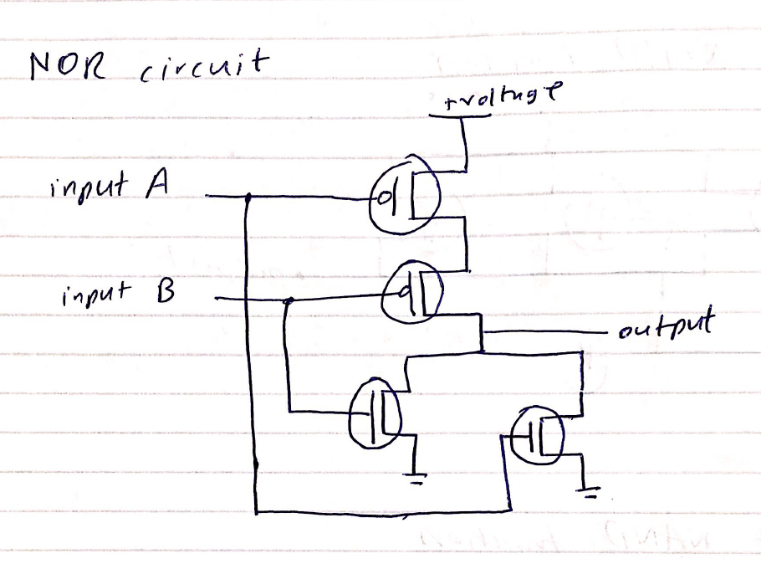

1. Name the Boolean function that this circuit implements.

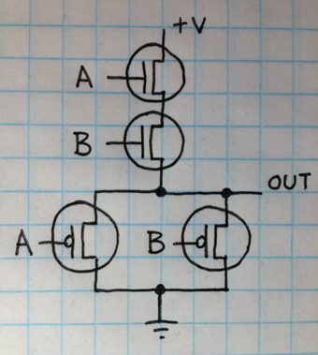

|  |  |  |
| --- | --- | --- |
| A | B | Output |
| 0 | 0 | 0 |
| 0 | 1 | 0 |
| 1 | 0 | 0 |
| 1 | 1 | 1 |

From the picture, I made the truth table above. From the table, we can see that the circuit is of the AND gate.

1. Let the input logic values to the following circuit be x=Don’t Care, y=0, and z=1. What is the logic value of the output f(x,y,z)?  
   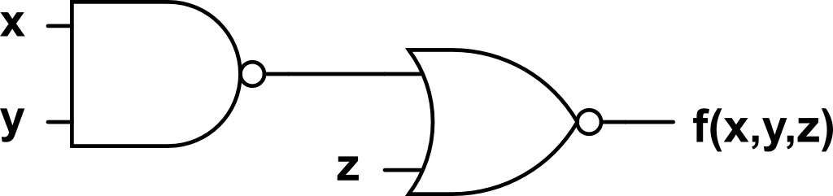

NAND of y = 0 and x = 0 or 1 is 1. And NOR of 1 and z = 1 is 1. So f(x,y,z) = 1.

1. Under what conditions does a full adder generate Sum = 0 and Carry out = 1 from Augend, Addend, and Carry in? Show your answer in the form of a table.

|  |  |  |  |  |
| --- | --- | --- | --- | --- |
| Input | | | Output | |
| Carry In | A | B | Sum | Carry out |
| 0 | 0 | 0 | 0 | 0 |
| 1 | 0 | 0 | 1 | 0 |
| 0 | 1 | 0 | 1 | 0 |
| 1 | 1 | 0 | 0 | 1 |
| 0 | 0 | 1 | 1 | 0 |
| 1 | 0 | 1 | 0 | 1 |
| 0 | 1 | 1 | 0 | 1 |
| 1 | 1 | 1 | 1 | 1 |

According to this there are three cases where there is a sum bit of 0 and a carryout bit of 1.

Cases are augend = 0, addend=1 and carry in = 1. Other case augend = 1, addend = 1 and carry in = 0. Last case is augend = 1, addend = 0 and carry in = 1.

1. What is the key idea that shows how to use fundamentally analog circuits so that they behave digitally?

The idea is to use a finite set of values and not the un accurate analogue. Using digital is better because numbers can be represented without error.

1. What principle allows for the simplification of descriptions of hardware by omission of unimportant detail?

The principle is to make a topic easier to understand by removing all the unimportant details. We want the jist of what is happening and don’t need to know the complete thing. An example is that the book tells us how the gates work but does not go into detail about how current is flowing in the circuit. It only tells us what we need to know.

1. You are given (zero cost of acquisition) a Cray-2 and an iPad 2 and quality places to operate them. Assume that both computers have the same application program that you wish to run. Assertion: Since these computers are equally fast, you have no preference as to which one you use. State whether you agree or disagree with the assertion and explain why.

I disagree with the assertion because there are significant differences between the two devices. It is not only about if both can run equally fast. The IPad is much more mobile, it is smaller in size, and it is much easier to use. The IPad consumes much lesser power and costs a lot less and that is why I would choose the IPad.